# CS 255 System Design Document Template

## UML Diagrams

### UML Use Case Diagram

### UML Activity Diagrams

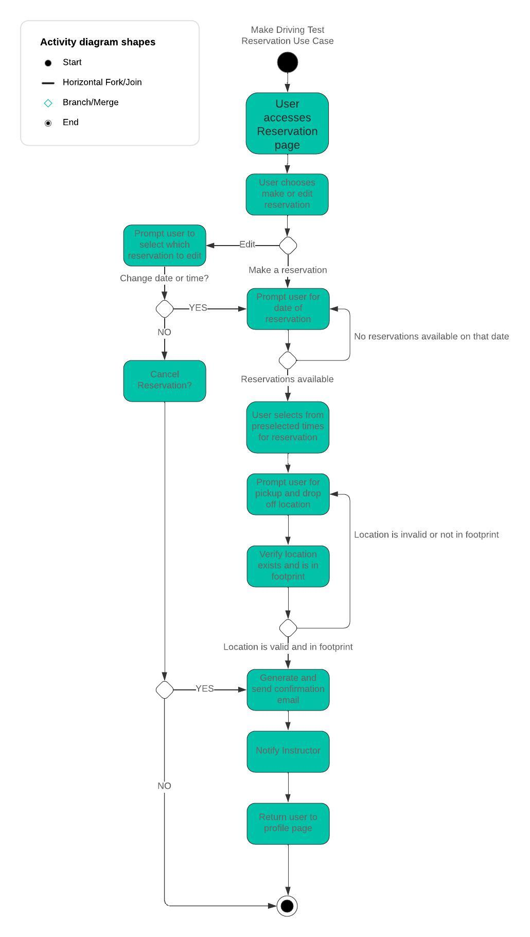

### UML Sequence Diagram

### UML Class Diagram

## Technical Requirements

Hardware:

* + Minimum of 3 computers to help run website.
  + Physical connections to the modem for at least one computer.
  + At least one hard drive to serve as physical backup of data.
  + Hardware is updated at minimum weekly.
  + Hardware life and performance evaluated yearly.

Software:

* + Windows operating system for each computer used.
  + Cloud storage through either OneDrive for Business or DropBox business.
    - Separate servers for system build and user information
  + Webhosting through a third party (HostGator, BlueHost, IONOS, etc).
  + All software must be decided on before building of system
  + Software is updated weekly.
  + Third party software services are examined yearly to ensure proper use of resources.

Infrastructure:

* Strong internet service preferably through fiber provider.